Content Guide for *Utopia*

UpStart 2025

University of Waterloo, Modern Languages, Theatre of the Arts

Wednesday, March 19th, 2025 to Saturday, March 22nd, 2025

Created on: February 12th, 2025

Last updated: February 20th, 2025

Version: 2

This guide provides information regarding moments in *Utopia* that require additional notice for audiences, such as content warnings, sudden lighting changes, or sonic environments that may cause discomfort. This guide does contain full show spoilers. As the show evolves throughout rehearsals, there may be changes to the content within this guide.

For more information regarding the show, please contact us at at UWtheatreperformance@gmail.com.

# Table of Contents

Spoiler-Full Plot Summary 3

General Content Warnings 9

A Timeline of the Show 10

Theatre of the Arts Layout 10

Timeline of show 11

Additional Resources 15

# Spoiler-Full Plot Summary

A woman emerges from the audience. She hears the echoes of people around her, speaking about a brand-new simulation called “Utopia.” She makes her way closer to the entrance. With one final push, she decides to enter into the simulation.

Two women emerge into their well put together home, bright music playing as they enter. We are inside the simulation and the women, wives Beatty and Charlotte, are preparing for a ‘Welcome to Utopia’ dinner party thrown in honour of their new neighbour, Mary Bradbury. Charlotte goes to the radio, turning down the music and busying herself with readying the house while Beatty goes to retrieve their centrepiece dish, a whole roasted pig. Charlotte looks to the audience, pulling out a remote and turning on an ‘applause’ sign, encouraging the audience to clap. Beatty returns and, after nearly dropping the pig on her way in, jokes with Charlotte not to scare this newcomer away like the last few. Charlotte dismisses Beatty, sharing her excitement for Mary to arrive and reading Mary’s entrance file. Beatty looks out their window at Mary’s new front lawn, noticing her apple tree. She asks Charlotte why they don’t have one, despite the simulation promising everything they desire. Charlotte dismisses Beatty once again. Beatty asks Charlotte about the simulation, expressing her unsuredness about the process of entering or what has happened to their bodies in the real world, but Charlotte comforts her and explains that they can go back to the real world anytime they wish. However, Charlotte encourages her to stay and Beatty agrees that she’d rather remain inside the simulation as a family.

The doorbell rings and Charlotte rushes to greet Mary. Mary enters, carrying a basket of apples from her tree, which instantly garners Beatty’s attention. Beatty pretends to eat one of Mary’s apples, exclaiming that it is delicious. Charlotte, though distasteful of the fruit, asks Mary about how she is liking her time in Utopia and if she is enjoying her tree. Mary expresses that it is something she always wanted, though she was never allowed to have it in the real world. Charlotte tells Mary her troubles are a thing of the past, as all her desires can be fulfilled inside Utopia.

Mary offers to help set the table, but is rebuked by Charlotte. Charlotte heads to the kitchen to finish preparing, leaving Beatty and Mary. Beatty and Mary begin chatting about their lives in Utopia. Beatty admits that, despite now having lived in Utopia for over 6 years, she still doesn’t quite understand the simulation like Charlotte does, but enjoys her time there. Beatty pretends to eat another of Mary’s apples, telling Mary of her desire to have a tree of her own, but that Charlotte won’t allow it due to pests. Mary asks for tips on how to deal with pests in her home. Charlotte re-enters and lets Mary know that the only way to deal with pests is to kill them.

Charlotte informs Mary that there is a surprise for her at this dinner party, and that he is on his way. Mary is confused by what Charlotte is referring to. The doorbell rings, and Charlotte announces the entrance of Johnny Perkins, Mary’s ex-husband from the real world. Johnny enters, warmly greeting his “wife” with an enthusiastic kiss. Mary breaks free from his grasp and moves away from him. Beatty reprimands Johnny for his forwardness, but Johnny brushes it off as excitement upon seeing his wife. Beatty questions Johnny about his behaviour, going so far as to imply he would take issue with her kissing her own wife. Charlotte stops Beatty and invites everyone to the table.

Charlotte asks Johnny to carve dinner for the group, handing him a kitchen knife. Johnny divides up the pig for the table. Everyone pretends to eat their meal, except for Mary, who is perplexed by their actions. Charlotte encourages Mary to share how she met her husband, but Mary refuses. Beatty suggests that she tell the story of how her and Charlotte met to ease the tension. Beatty begins to share that her and Charlotte met at the front gates of Utopia when Beatty first arrived. They had been together ever since.

Charlotte begins to discuss how finding love was something she had always wanted, but was never able to have in the real world. Throughout her original life, she had experienced extreme homophobia which prevented her from living her life as she desired. However, she abruptly cuts herself off upon noticing the radio has begun to shoot out sounds of static. She laughs off her story with Johnny, inviting Mary to tell her story now.

Mary continues to hesitate to discuss how her and Johnny met, but is eventually convinced. She explains that they met in a market in the real world while shopping for fruit when Johnny approached her and made a joke about her attractiveness. While Johnny and Charlotte find his joke hilarious, Beatty is unamused. Beatty pushes back against Johnny and is sent away to the kitchen by Charlotte.

With Beatty gone, Charlotte and Johnny’s conversation begins to make Mary uncomfortable, but Charlotte stops Mary from leaving. Mary lashes out at Johnny, questioning why he has chosen to enter the simulation. Charlotte and Johnny begin insisting Mary is delirious, saying she should go home to rest. Mary refuses. Beatty returns to the dining room upon hearing the commotion. Mary asks if they know what Johnny did, but neither Charlotte nor Beatty answer her. Mary says she would like to go back to the real world, but is told by Charlotte that she can’t. Beatty challenges Charlotte, saying that she also wants to leave. She tells Charlotte they can be a family together in the real world, but Charlotte refuses, encouraging Beatty to have another of Mary’s apples. Beatty says that she is tired of pretending to live her life, unable to even taste the apples as she “eats” them. Mary encourages Beatty to actually take a bite of one of the apples. Beatty bites the apple, and is instantly overcome with pain. Her mouth begins to bleed as she chokes on it, collapsing to the ground.

Mary begins to experience a flashback of her life before Utopia. She recalls an argument she had with her ex-husband John about her desire to enter the simulation. Despite their separation, John continues to exert control over her life, stating that he is going to fix their situation once he is able to land a job. As the argument continues, John becomes increasingly violent towards Mary, shouting and belittling her. John tells Mary that they will never enter Utopia.

Mary is brought back to the present, sitting alone at the dinner table in Charlotte and Beatty’s house, Beatty’s blood still staining the floor. Johnny begins to play her some music to calm her down, but it is ineffective. The two argue and Mary says to Johnny that she hates the terror he has enacted over her life, telling him she will never feel safe as long as he is in Utopia. Johnny threatens Mary, causing her to grab the kitchen knife on the table. Mary and Johnny fight, and Mary stabs Johnny to death.

Mary looks at Johnny’s body, and then the audience. She picks up an apple left behind by Beatty, and pretends to take a bite of it. Charlotte enters, laughing alongside Mary and taking the knife from her. Mary realizes that Charlotte has been pushing her to kill Johnny all along, fulfilling her desire to be free from him. Charlotte and Mary embrace.

# General Content Warnings

Please note, this show contains simulated intimacy, references to homophobia, depictions of domestic violence, coarse and aggressive language, simulated violence (including stabbing), and simulated blood and gore.

Graphic depictions within this production are undertaken with the purpose of serving the overall story. All instances of simulated violence and harm have undergone an extensive rehearsal process for the safety of those involved in the production. If at any point you wish to leave the theatre, please exit up the aisles into the lobby.

# A Timeline of the Show

## Theatre of the Arts Layout

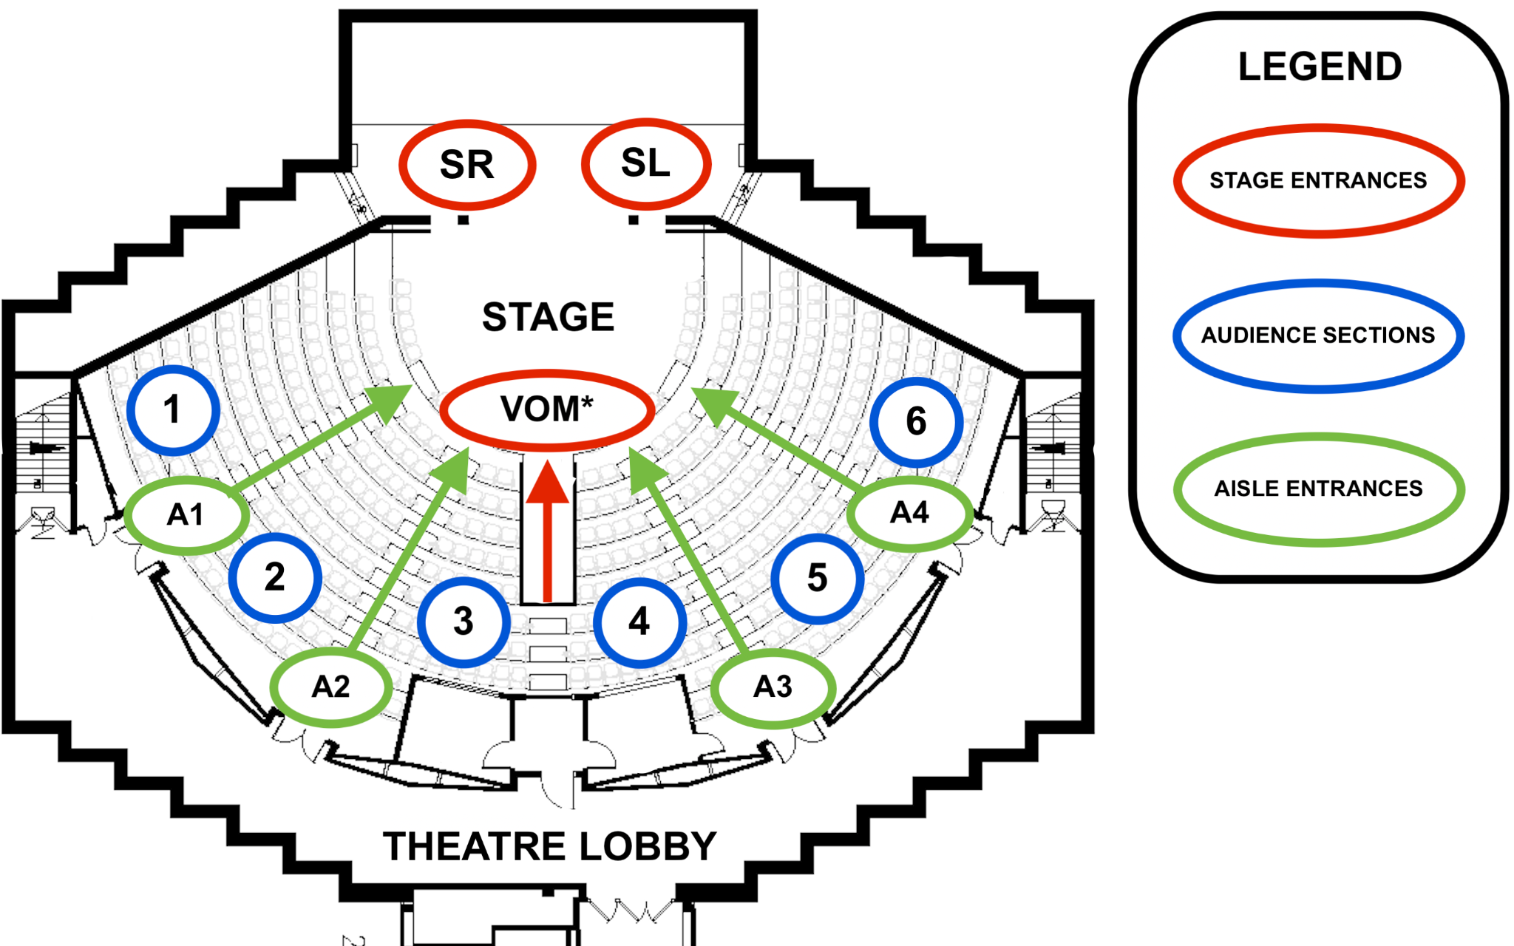

*\*Please note, VOM entrance emerges from lower level underneath audience.*

*\*\*Please note, speakers are located along the back wall of the theatre and sound may be more pronounced when sitting nearby them.*

## Timeline of show

**–00:06:44**

**00:00:04 –** Mary emerges from audience section 5 and moves a down A3 towards the stage.

**00:01:11 –** Mary exits down the VOM.

**00:01:15 –** Music begins to play and the lights brighten. Charlotte and Beatty enter from SR.

**00:02:03 –** Music is stopped.

**00:10:30 –** Charlotte talks about killing “pests,” while holding a kitchen knife. The kitchen knife is a metal knife with a wooden handle that has been dulled and tested for actor safety.

***Preceding Line:*** *Johnny - “In the flesh.”*

**00:11:45 –** Johnny kisses Mary against her will.

***Preceding Line:*** *Beatty - “Yeah…how would you feel if I kissed my wife, Johnny?”*

**00:12:12 –** Johnny makes a homophobic comment – *“I have no issues with the LGBTQ community…however–”*

**00:12:35 –** Johnny startles Mary by grabbing her shoulders.

**00:13:00 –** Johnny cuts up a roasted pig using a dinner knife.

***Preceding Line:*** *Charlotte - “Thank you…I think about it sometimes.”*

**00:16:29 –** Charlotte discusses the homophobia she experienced in the real world. There is a static sound effect.

***Preceding Line:*** *Johnny - “I always try to ignore broads that bite back.” Beatty – “I’m sorry, who the fu–”*

**00:19:54 –** Beatty gestures aggressively at Johnny with a butter knife.

***Preceding Line:*** *Beatty - “We can leave and go be a family together in the real world. We don’t have to pretend anymore; we can finally be free!”*

**00:25:37 –** Charlotte yells “I am not fucking leaving!”

***Preceding Line:*** *Charlotte - “Actions have consequences.”*

**00:26:46 –** Beatty bites an apple and begins choking and coughing. There is a static sound effect. Fake blood pours from her mouth. There is shouting from the other characters.

**00:27:45 –** Mary’s flashback begins. The lighting becomes darker and there is a sound of static. Throughout this scene, there are depictions of domestic violence.

**00:27:57 –** John slams a wine bottle onto the counter.

**00:28:13 –** John picks up the dinner knife and gestures to his neck. He continues to gesture with the knife in his hand.

**00:28:21 –** John yells at Mary while gesturing with knife at her - “You need to listen to me and listen good, bitch!”

**00:28:56 –** John slams the knife down on the table.

**00:29:57 –** The lighting brightens. Johnny enters SR and turns on the radio. Music plays.

**00:30:33 –** Music is stopped.

***Preceding Line:*** *Johnny crosses towards Mary from SR to SL - “Mary, I could fucking kill you and no one would–”*

**00:32:24 –** Mary breaks away from Johnny and grabs the kitchen knife. Johnny and Mary shout at each other as Mary threatens him with the knife. Johnny attempts to get the knife from Mary so she tries to stab him, which he dodges. Johnny grabs Mary’s hands and pulls her around in front of him. Mary shoves him on to the table and slashes his arm. Mary slashes Johnny’s face. Mary stabs Johnny three times. Mary is covered in fake blood.

# 

# 

# Additional Resources

The [Family Violence Project of Waterloo Region](https://familyviolenceprojectwr.ca) has compiled a list of local resources for those experiencing domestic violence: [www.familyviolenceprojectwr.ca/resources](https://familyviolenceprojectwr.ca/resources/)

[Victim Services of Waterloo Region](https://www.vswr.ca/about/) has also compiled various resources for information regarding domestic violence: [www.vswr.ca/domestic-violence](https://www.vswr.ca/domestic-violence/)

Here 24/7 is an organization that connects community members to addictions, mental health, and crisis services in Waterloo Region: [www.here247.ca](https://here247.ca/)

For mental health support, Good2Talk is a mental health support service for post-secondary Students in Ontario: [www.good2talk.ca/ontario](https://good2talk.ca/ontario/about/)

For a list of mental and physical health support services on campus, please visit: [www.uwaterloo.ca/students/health-and-well-being](http://www.uwaterloo.ca/students/health-and-well-being)